NAME: Tony Winston T

REG NO: 1924260006

COURSE CODE: CSA0704

SLOT: A

ASSESSMENT TOOL-CO5 AT2

Question 1: P2P File Sharing Algorithm
Arrange the blocks in this order:
- START
- CONNECT TO PEER
- IF FILE IS AVAILABLE THEN
- DOWNLOAD FILE
- ENDIF
- DISPLAY "File not available"
- END
Correct algorithm would need:
IF FILE IS AVAILABLE THEN → DOWNLOAD FILE → ELSE → DISPLAY "File not available" → END

FLOWCHART:

Question 1: P2P File Sharing Algorithm

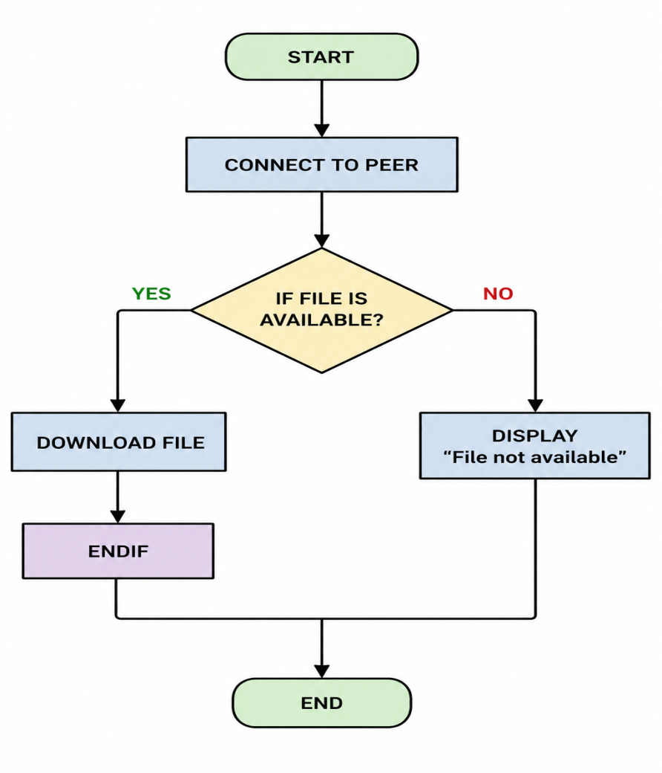

Question 2: VoIP Call Connection Algorithm
Arrange the blocks in this order:
- START
- CHECK INTERNET CONNECTION
- IF INTERNET IS AVAILABLE THEN
- CONNECT CALL
- START VOICE COMMUNICATION
- ELSE
- DISPLAY "No Internet Connection"
- ENDIF
- END
FLOWCHART:
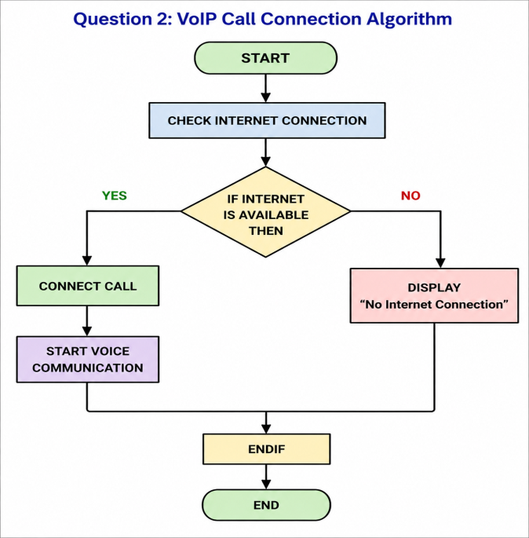

Question 3: Correct Algorithm Sequence
- START
- CHECK DESTINATION NODE
- IF DESTINATION NODE IS AVAILABLE THEN
- SEND MESSAGE DIRECTLY
- ELSE
- FORWARD MESSAGE THROUGH ANOTHER NODE
- DISPLAY "MESSAGE SENT"
- ENDIF
- END

FLOWCHART:

